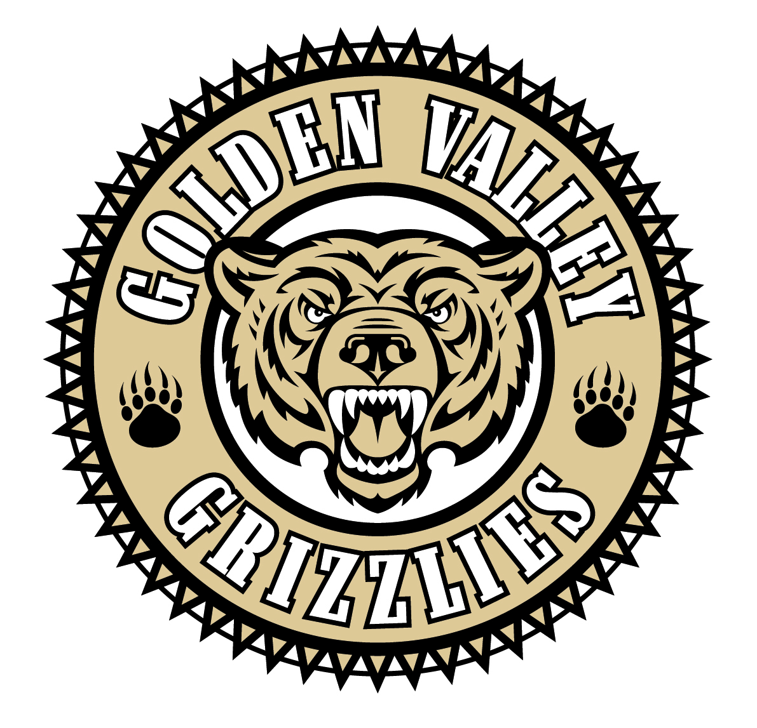
Golden Valley High School
Wm. S. Hart Union High School District
“Home of the Grizzlies”
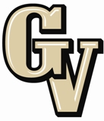

Parent Advisory Council (PAC) Meeting
September 26, 2016
6:30 PM

AGENDA

- PAC Meeting Welcome Sal Frias

- Secretary’s Report ACTION

- Treasurer’s Report ACTION

- President’s Report Colleen Villani

- District Advisory Council (DAC) Report Carmen McCray

- Parent Communications Council (PCC) Report Suzanne Holmes

- 2016-17 Intervention Lesley Day

- Math Department Presentation Lesley Day and Kim Jimenez

- Dealing with school issues Colleen Villani

- Safe School Plans and Active Shooter Drills Joel Nelson

Announcements: - Back to Sports Night on 9/27 in Library at 6 pm
- Choir Parent Meeting on 09/27 in choir room at 6:30 pm
- Boys Basketball Booster Meeting on 9/29 at 6:30 in Library
- Fall Break is 10/3 and 10/4
- Band Booster Meeting on 10/11 at 7 pm in room 607
- Cash for College Workshop on 10/12 at 5:30 pm in the Library
- End of Quarter 1 on 10/14
- PSAT Sales for 11th graders through 10/14
- PSAT Sales for 9th and 10th grades are 10/3 through 10/14
- DTASC on 10/20 at 6 pm in GVHS Theater
- Boys Basketball Booster Meeting on 10/26 in Staff Lounge

Next Meeting: October 24, 2016 @ 6:30 pm at GVHS Library

The mission of GVHS is to provide a quality education to a diverse student population, develop each student’s maximum potential, and prepare students for success in the global community.

